Go to: https://www.penny-hunt.co.uk/penny-hunt-artist-workshops 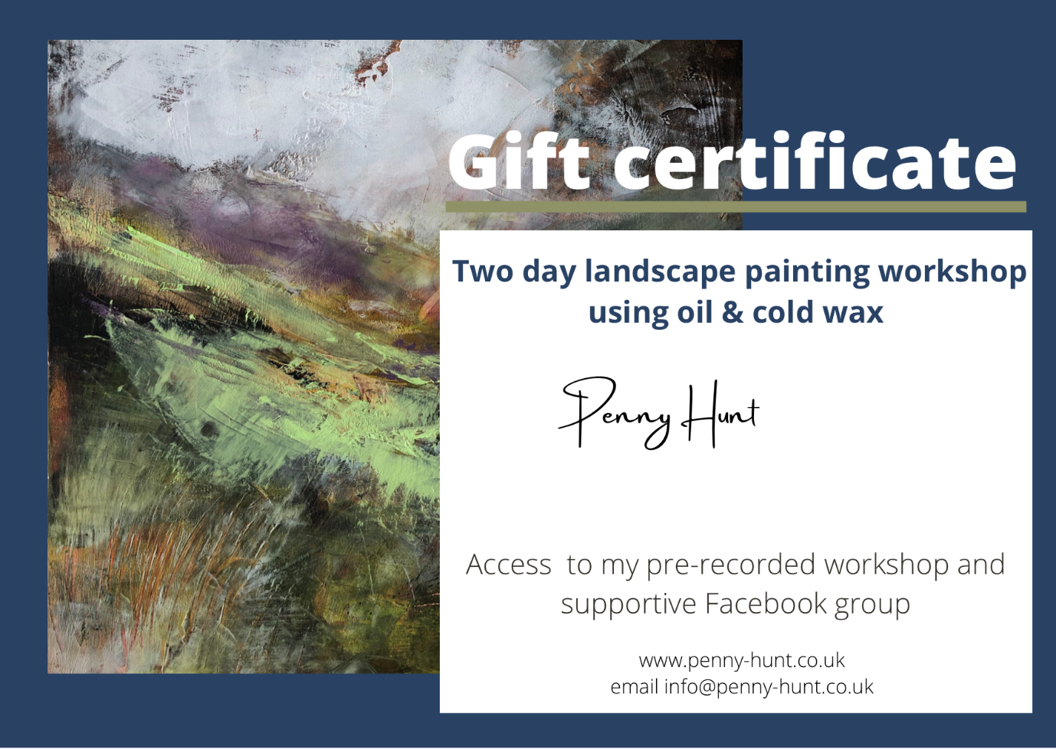
Password for the month: _______________________ Voucher Number ____

